Week 2 Penetration Testing Report

Introduction

This report document hereby describes the proceedings and results of a Black Box security assessment conducted against the Week 2 Labs. The report hereby lists the findings and corresponding best practice mitigation actions and recommendations.

1. Objective

The objective of the assessment was to uncover vulnerabilities in the Week 2 Labs and provide a final security assessment report comprising vulnerabilities, remediation strategy, and recommendation guidelines to help mitigate the identified vulnerabilities and risks during the activity.

2. Scope

This section defines the scope and boundaries of the project.
Application Name | {HTML Injection}, {Clickjacking}

3. Summary

Outlined is a Black Box Application Security assessment for the Week 2 Labs.

Total number of Sub-labs: 8 Sub-labs

High | Medium | Low
1 | 3 | 4

High - Number of Sub-labs with hard difficulty level
Medium - Number of Sub-labs with Medium difficulty level,
Low - Number of Sub-labs with Easy difficulty level

1. {HTML Injection}

1.1. {HTML’s are easy!}

Reference | Risk Rating
HTML’s are easy! | Low
Tools Used
Google chrome.
Vulnerability Description
I found this vulnerability by using basic HTML tags i.e., h1 tag.
How It Was Discovered
Manual Analysis.
Vulnerable URLs
https://www.bugbountyhunter.org/internship_labs/HTML/html_lab/lab_1/html_injection_1.php
Consequences of not Fixing the Issue
This can lead to managing and accessing other web pages and it can lead to phishing other users.
Suggested Countermeasures
Sanitize the input by validating canonical tags (<>) and slash (/). or < > ( ) ‘ “ / \ * ; : = { }.
References
I used basic knowledge of HTML to discover this vulnerability.

Proof of Concept

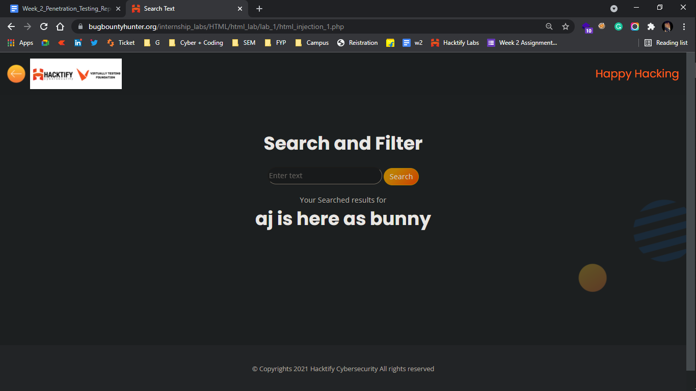

1.2. {Let me store them}

Reference | Risk Rating
Let me store them | Low
Tools Used
Google chrome.
Vulnerability Description
I found this vulnerability by trying multiple HTML tags on different input fields. Here I am able to run every HTML valid code to inject malicious code.
How It Was Discovered
Manual Analysis.
Vulnerable URLs
https://www.bugbountyhunter.org/internship_labs/HTML/html_lab/lab_2/html_injection_2.php
Consequences of not Fixing the Issue
To steal another person's identity.
Suggested Countermeasures
Sanitize the input by validating canonical tags (<>) and slash (/). or < > ( ) ‘ “ / \ * ; : = { }.
References
https://owasp.org/www-project-web-security-testing-guide/latest/4-Web_Application_Security_Testing/11-Client-side_Testing/03-Testing_for_HTML_Injection

Proof of Concept

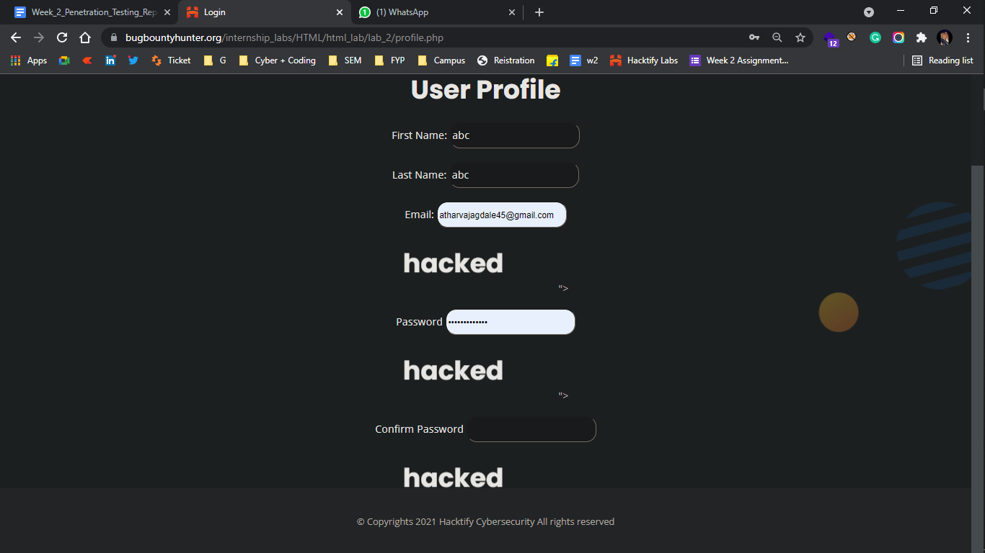

1.3. {File names are also vulnerable}

Reference | Risk Rating
File names are vulnerable | Low
Tools Used
Google chrome and BurpSuite
Vulnerability Description
I found this vulnerability by intercepting a web app on burpsuite and changing the filename on it to forward back on the web to a successful run.
How It Was Discovered
Manual Analysis as well as automated analysis
Vulnerable URLs
https://www.bugbountyhunter.org/internship_labs/HTML/html_lab/lab_3/html_injection_3.php
Consequences of not Fixing the Issue
Malicious file names may distract the user and also it can cause the user to do something illegal or wrong on the web.
Suggested Countermeasures
Sanitize the input by validating canonical tags (<>) and slash (/). or < > ( ) ‘ “ / \ * ; : = { } and it should not accept any of these tags by external resources also.
References
https://owasp.org/www-project-web-security-testing-guide/latest/4-Web_Application_Security_Testing/11-Client-side_Testing/03-Testing_for_HTML_Injection

Proof of Concept

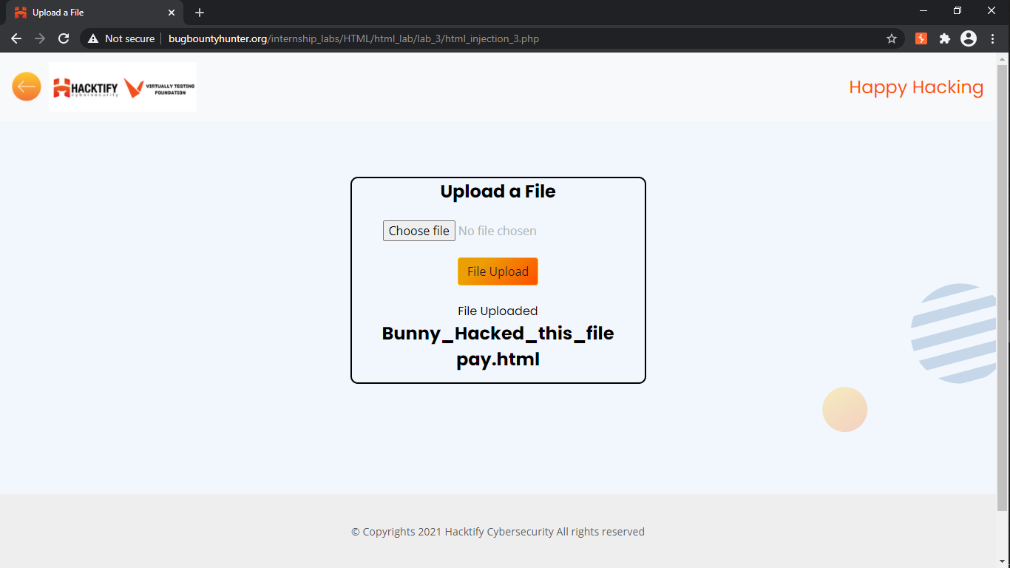

1.4. {File content and HTML Injection a perfect pair}

Reference | Risk Rating
File content and HTML Injection are a perfect pair | Medium
Tools Used
Google chrome
Vulnerability Description
I found this vulnerability by just uploading malicious file in the file uploading section with different file extensions and containing malicious code in it.
How It Was Discovered
Manual Analysis
Vulnerable URLs
https://www.bugbountyhunter.org/internship_labs/HTML/html_lab/lab_4/html_injection_4.php
Consequences of not Fixing the Issue
It can lead to taking down an entire website and the website will show wrong data content on the website.
Suggested Countermeasures
Sanitization of file extensions that it should accept only required files with valid and specified file extensions
References
https://owasp.org/www-project-web-security-testing-guide/latest/4-Web_Application_Security_Testing/11-Client-side_Testing/03-Testing_for_HTML_Injection

Proof of Concept

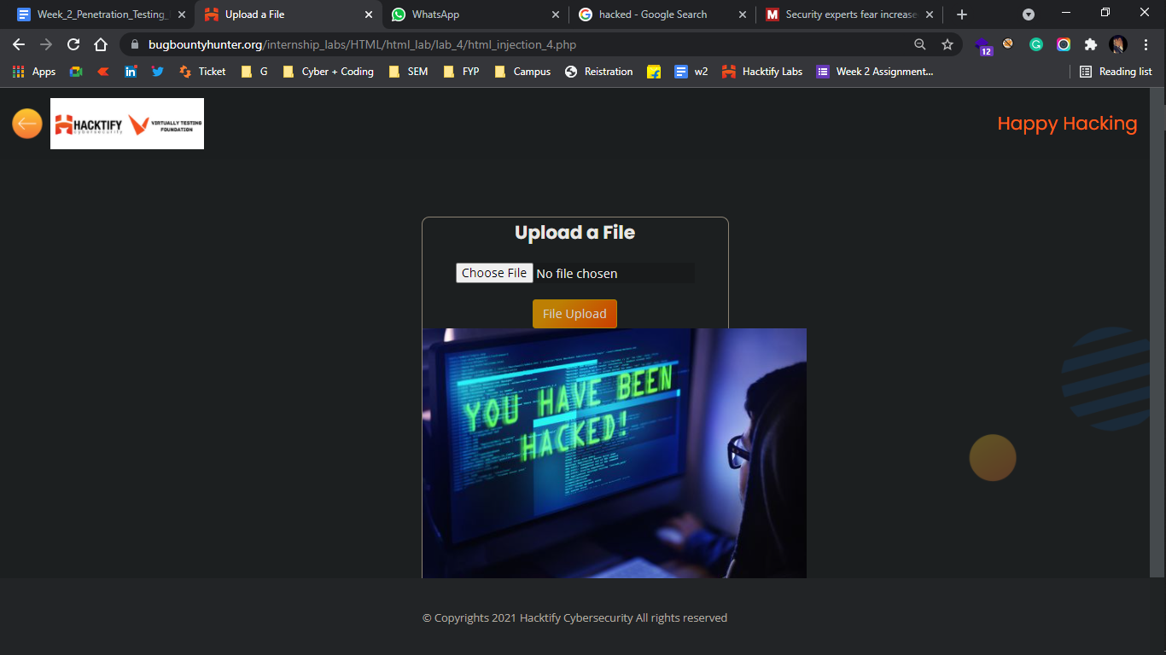

1.5. {Injecting HTML using URL}

Reference | Risk Rating
Injecting HTML using URL | Medium
Tools Used
Google chrome
Vulnerability Description
I found this vulnerability by tampering actual website of the code and injecting valid HTML code as malicious cod or payload
How It Was Discovered
Manual Analysis
Vulnerable URLs
https://www.bugbountyhunter.org/internship_labs/HTML/html_lab/lab_5/html_injection_5.php
Consequences of not Fixing the Issue
It can allow attacker modify the URL and modify the web pages
Suggested Countermeasures
Invalid URL should not work or should display errors to the user
References
https://owasp.org/www-project-web-security-testing-guide/latest/4-Web_Application_Security_Testing/11-Client-side_Testing/03-Testing_for_HTML_Injection

Proof of Concept

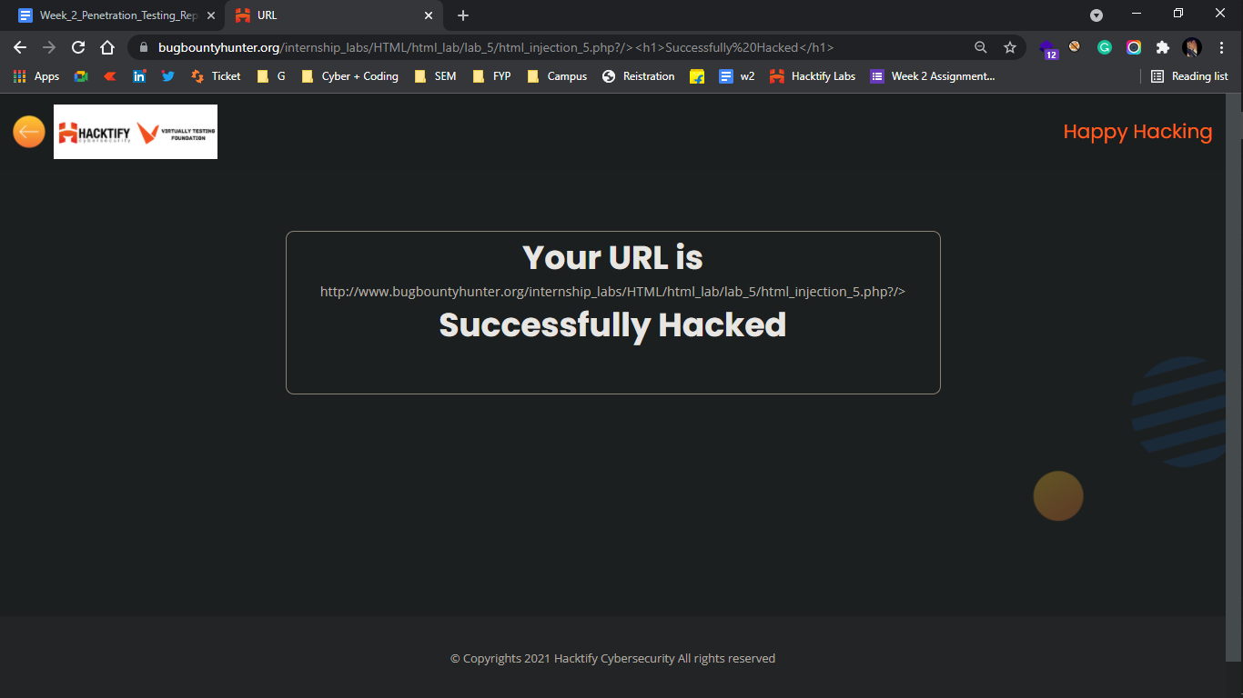

1.6. {Encode it}

Reference | Risk Rating
Encode it | High
Tools Used
Google chrome and Burp Suite
Vulnerability Description
I found this vulnerability by entering basic HTML valid code by encoding it into URL encoder
How It Was Discovered
Manual Analysis and automated analysis
Vulnerable URLs
https://www.bugbountyhunter.org/internship_labs/HTML/html_lab/lab_6/html_injection_6.php
Consequences of not Fixing the Issue
This can lead to managing and accessing other web pages and it can lead to phishing other users.
Suggested Countermeasures
Sanitize the input by validating canonical tags (<>) and slash (/). or < > ( ) ‘ “ / \ * ; : = { } also encoding with the help of other external tools
References
https://owasp.org/www-project-web-security-testing-guide/latest/4-Web_Application_Security_Testing/11-Client-side_Testing/03-Testing_for_HTML_Injection

Proof of Concept

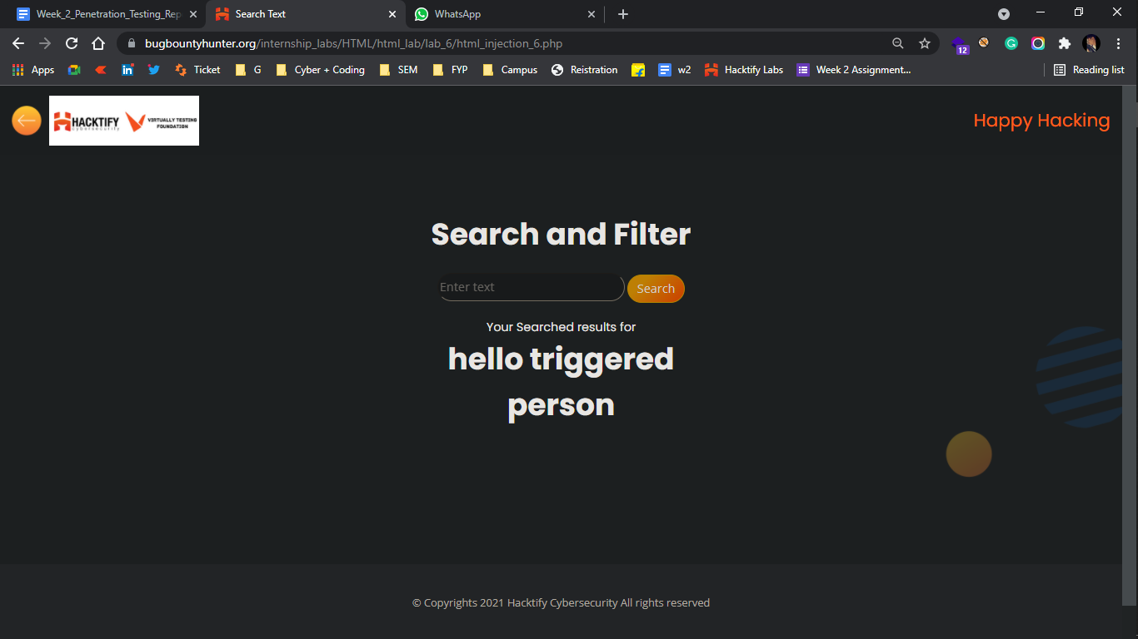

2. {Clickjacking}

2.1. {Let’s Hijack}

Reference | Risk Rating
Let’s Hijack | Low / Medium / High
Tools Used
Google Chrome
Vulnerability Description
I found this vulnerability by clicking on the direct link of the external page link which is directly available on the page source option.
How It Was Discovered
Manual Analysis
Vulnerable URLs
https://www.bugbountyhunter.org/internship_labs/HTML/clickjacking_lab/lab_1/lab_1.php
Consequences of not Fixing the Issue
This is an interface-based attack in which a user is tricked into clicking on actionable content on a hidden website by clicking on some other content in a decoy website.
Suggested Countermeasures
Important page links should not be easily available on the page source option or it must be in encoded format. and the user must check what they are reaching out after clicking on a particular button.
References
https://owasp.org/www-community/attacks/Clickjacking
https://cheatsheetseries.owasp.org/cheatsheets/Clickjacking_Defense_Cheat_Sheet.html

Proof of Concept
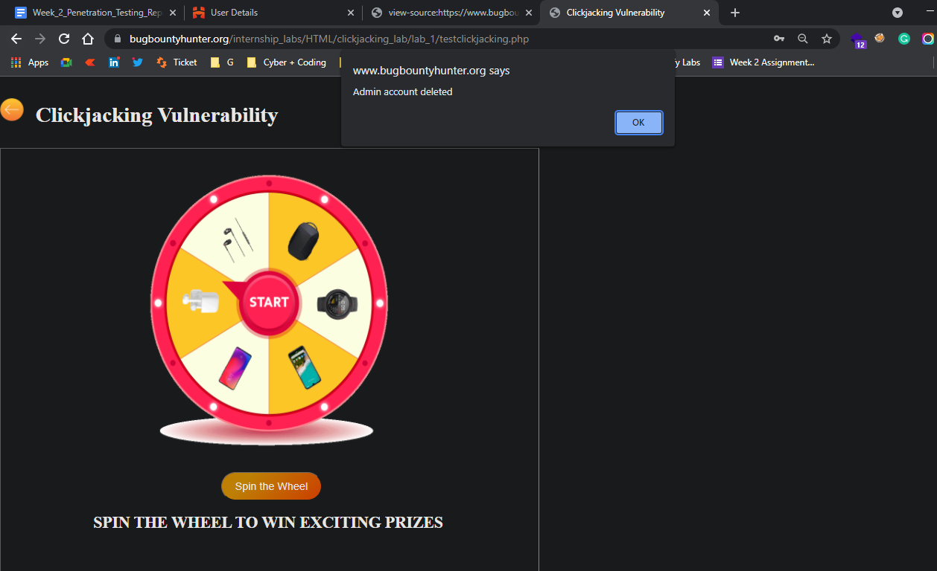

2.2. {Re-Hijack}

Reference | Risk Rating
Re-Hijack | Medium
Tools Used
Google chrome
Vulnerability Description
I found this vulnerability by clicking on the direct link of the external page link which is directly available on the page source option.
How It Was Discovered
Manual Analysis
Vulnerable URLs
https://www.bugbountyhunter.org/internship_labs/HTML/clickjacking_lab/lab_2/lab_2.php
Consequences of not Fixing the Issue
This is an interface-based attack in which a user is tricked into clicking on actionable content on a hidden website by clicking on some other content in a decoy website.
Suggested Countermeasures
Important page links should not be easily available on the page source option or it must be in encoded format. and the user must check what they are reaching out after clicking on a particular button.
References
https://owasp.org/www-community/attacks/Clickjacking
https://cheatsheetseries.owasp.org/cheatsheets/Clickjacking_Defense_Cheat_Sheet.html

Proof of Concept

